**Media Sentiment and the Stock Market**

Team Members: Jess Alcalde, Christian Attard, Nitin Khade, Rachel Torres

**What is the impact of news on the stock market?**

The analysis suggests little correlation between news and index performance when looking at all news. However, when news is narrowed to that which relates to finance or politics the data suggests a strong alignment of sentiment and market movement, with neutral sentiment resulting in no movement or positive movement.

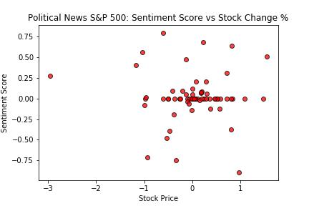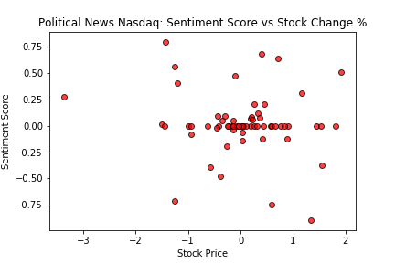

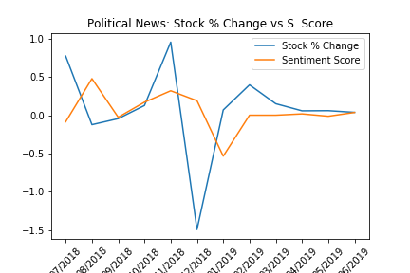Unexpectedly, the movement of the news seems to follow the movement of the index, not the other way around. Seemingly, investors are impacted by the information in the news but are ahead of the reporting of it. With no way of identifying if the news was expected or unexpected it is impossible to determine whether or not the market had already accounted for it.

**How influential is a public scandal on a company’s stock price?**

Stock behavior and news analysis of 3 companies, in different market sectors, revealed that negative sentiment due to scandal only caused short term losses. The stock behavior is controlled by what appears to be more influential factors.

**Wells Fargo:**

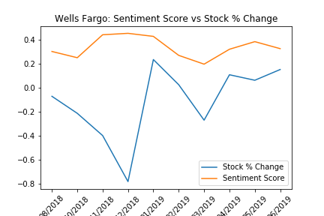In December 2018 news sentiment towards Wells Fargo was positive and remained so in the midst of a steady decline in stock value, seemingly having no influence. However, from Jan - March 2019 decreasing news sentiments align with a decrease in stock value, both recovering shortly after.

**Tesla:**

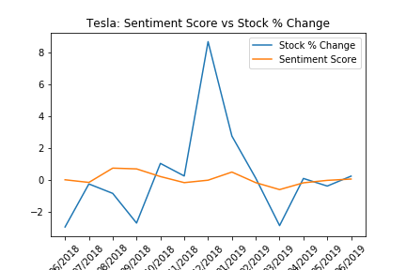Similarly to Wells Fargo, fluctuations in stock value are uninfluenced by stable news sentiments. However, declining news sentiments in September agree with a temporary decline in stock value.

**Wayfair:**

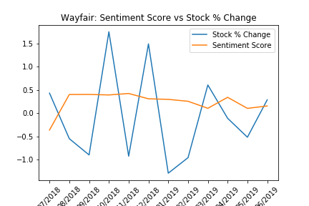News sentiments for Wayfair remained positive overall until April 2019 when we observe a dip in both sentiment and stock price, followed immediately by a rebound in first the news then the stock price. This likely indicates a reaction surrounding reported first quarter earnings. However, the scandal in June showed little impact on the stock’s value.

While the news sentiment and stock/index behavior is correlated, additional analysis would be necessary to determine causality. To explore further, data sets can be narrowed by date and other influential factors can be introduced to rule out their level of impact.